Day12&13 - Bash Scripting and CronTab Entries

GitHub SSH Setup from Amazon Linux EC2 - Follow all the below commands and instructions to setup install git, setup a repository and push your first commit
- Install Git
sudo yum update -y
sudo yum install git -y
Verify: git --version
- Configure Git
Replace with your details.
git config --global user.name "rampotnuru"
git config --global user.email "pavanram.potnuru@gmail.com"
Verify: git config --list
- Create a new SSH key.
ssh-keygen -t ed25519 -C "pavanram.potnuru@gmail.com"
When prompted:
Enter file in which to save the key
Provide a custom filename:
/home/ec2-user/.ssh/git_token
Press Enter.
For passphrase: Press Enter twice to leave it blank.
Expected files:
~/.ssh/git_token
~/.ssh/git_token.pub
- Verify Key Creation
ls -la ~/.ssh
Expected:
git_token
git_token.pub
Known_hosts
- Display Public Key
cat ~/.ssh/git_token.pub
Copy the entire output.
Example:
ssh-ed25519 AAAAC3NzaC1lZDI1NTE5AAAAI...... pavanram.potnuru@gmail.com
- Add Public Key to GitHub
Navigate to:
GitHub → Profile → Settings → SSH and GPG Keys
Click:
New SSH Key
Fill:
Title: Amazon Linux EC2
Key Type: Authentication Key
Key: <paste public key>
Save.
- Configure SSH to Use the Key
Create SSH config file:
vi ~/.ssh/config
Add:
Host github.com
HostName github.com
User git
IdentityFile ~/.ssh/git_token
Save:
ESC
:wq
Set permissions:
chmod 600 ~/.ssh/config
chmod 600 ~/.ssh/git_token
chmod 644 ~/.ssh/git_token.pub
- Test GitHub Authentication
ssh -T git@github.com
Expected:
Hi rampotnuru! You've successfully authenticated, but GitHub does not provide shell access.
- Create Project Directory
mkdir bash_scripting
cd bash_scripting
- Initialize Git Repository
git init
Rename default branch:
git branch -M main
- Create Project Structure
mkdir scripts
mkdir crontab
Verify:
tree
Expected:
.
├── crontab
└── scripts
- Create Repository on GitHub
Create an empty repository named: bash_scripting
Do NOT select:
README
.gitignore
License
- Connect Local Repository to GitHub
Add remote:
git remote add origin git@github.com:rampotnuru/bash_scripting.git
Verify:
git remote -v
Expected:
origin git@github.com:rampotnuru/bash_scripting.git
origin git@github.com:rampotnuru/bash_scripting.git
- Create First Commit
Create README:
touch README.md
Add files:
git add .
Commit:
git commit -m "Initial repository structure"
- Push to GitHub
First push:
git push -u origin main
Subsequent pushes:
git push
________________________________________________________________
TASKS:

- Create a bash script to check if a directory is available or not.
  - nano search_dir.sh - Create a new file and paste the below contents
  - #!/bin/bash
read -p "Enter the directory name/path: " dir

if [ -d "$dir" ]
then
echo "Directory exists."
else
echo "Directory does not exist."
fi
  - chmod +x search_dir.sh - Giving execute permissions to search_dir.sh
  - bash search_dir.sh (or) ./search_dir.sh - Commands to run the script
  - git add scripts/search_dir.sh - This command adds the script to the git staging area where scripts will get ready to commit
  - git commit -m “Added a script to search directories” - This command commits the code into github
  - git push - This command is used to push the final code to the existing git repository.
  - git log --oneline - Command used to verify commit history
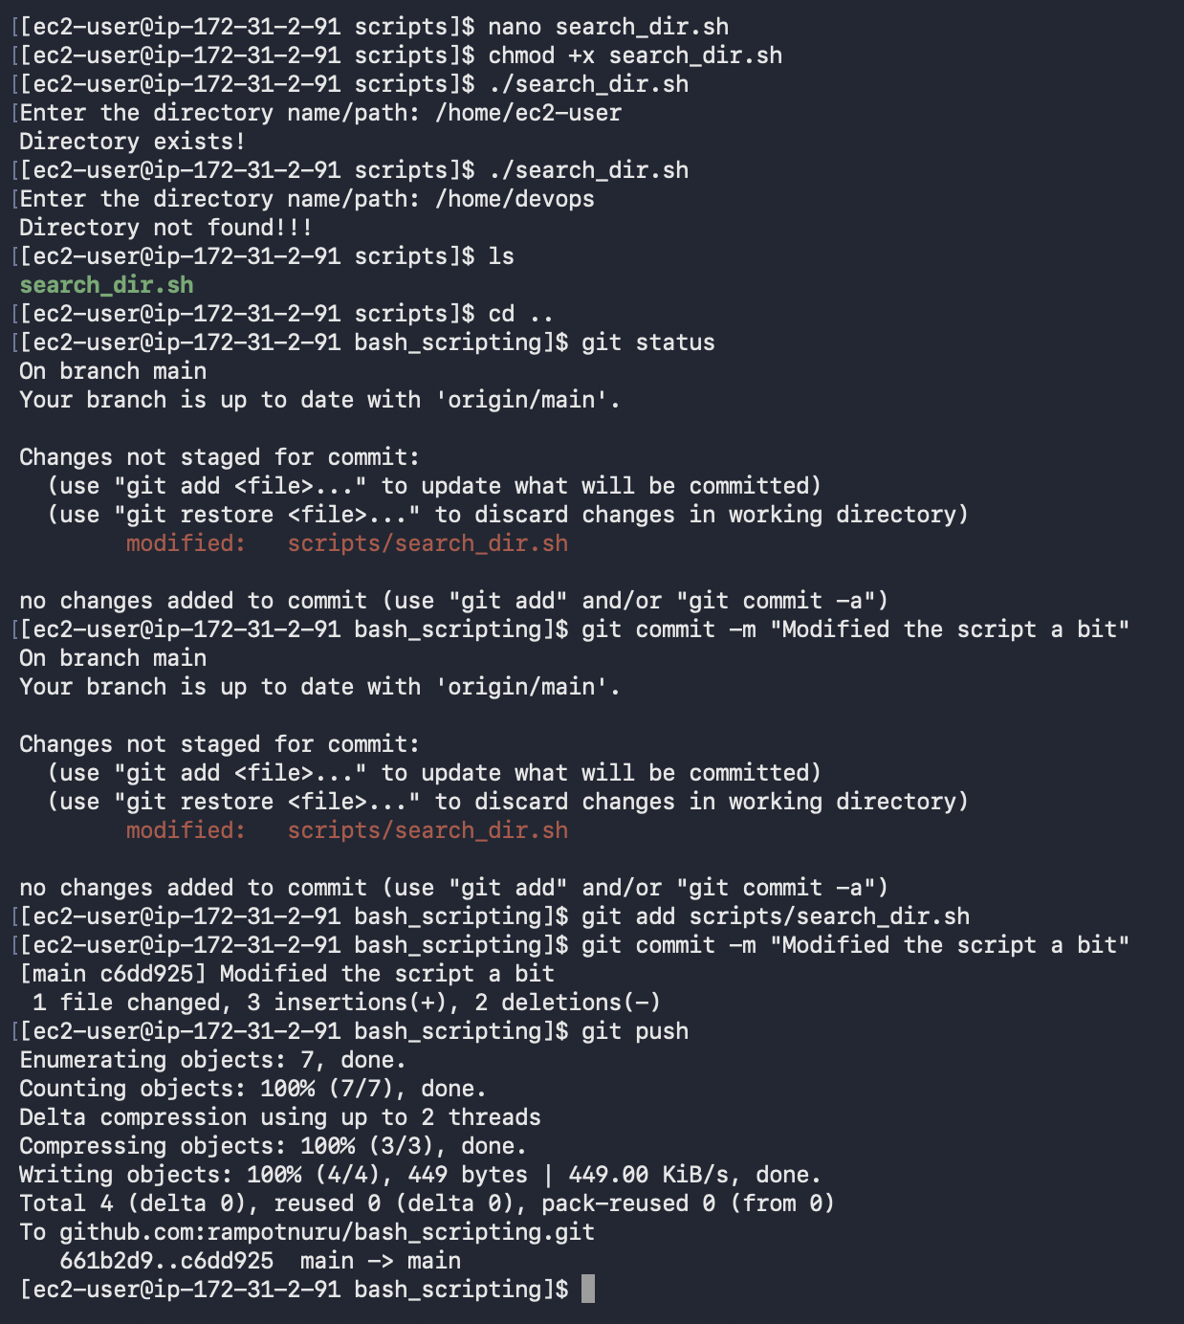

- Create a bash script to create multiple files.
  - nano mul_files.sh - Create a new file and paste the below contents
  - #!/bin/bash
read -p "Enter how many files do you want to create? : " count

for ((i=1;i<=count;i++))
do
touch file-$i.txt
done
  - bash -n mul_files.sh - Command used to validate the script
  - chmod +x mul_files.sh - Giving execute permissions to mul_files.sh
  - bash mul_files.sh (or) ./mul_files.sh - Commands to run the script
  - git add scripts/search_dir.sh - This command adds the script to the git staging area where scripts will get ready to commit
  - git commit -m “Added a script to search directories” - This command commits the code into github
  - git push - This command is used to push the final code to the existing git repository.
  - git log --oneline - Command used to verify commit history
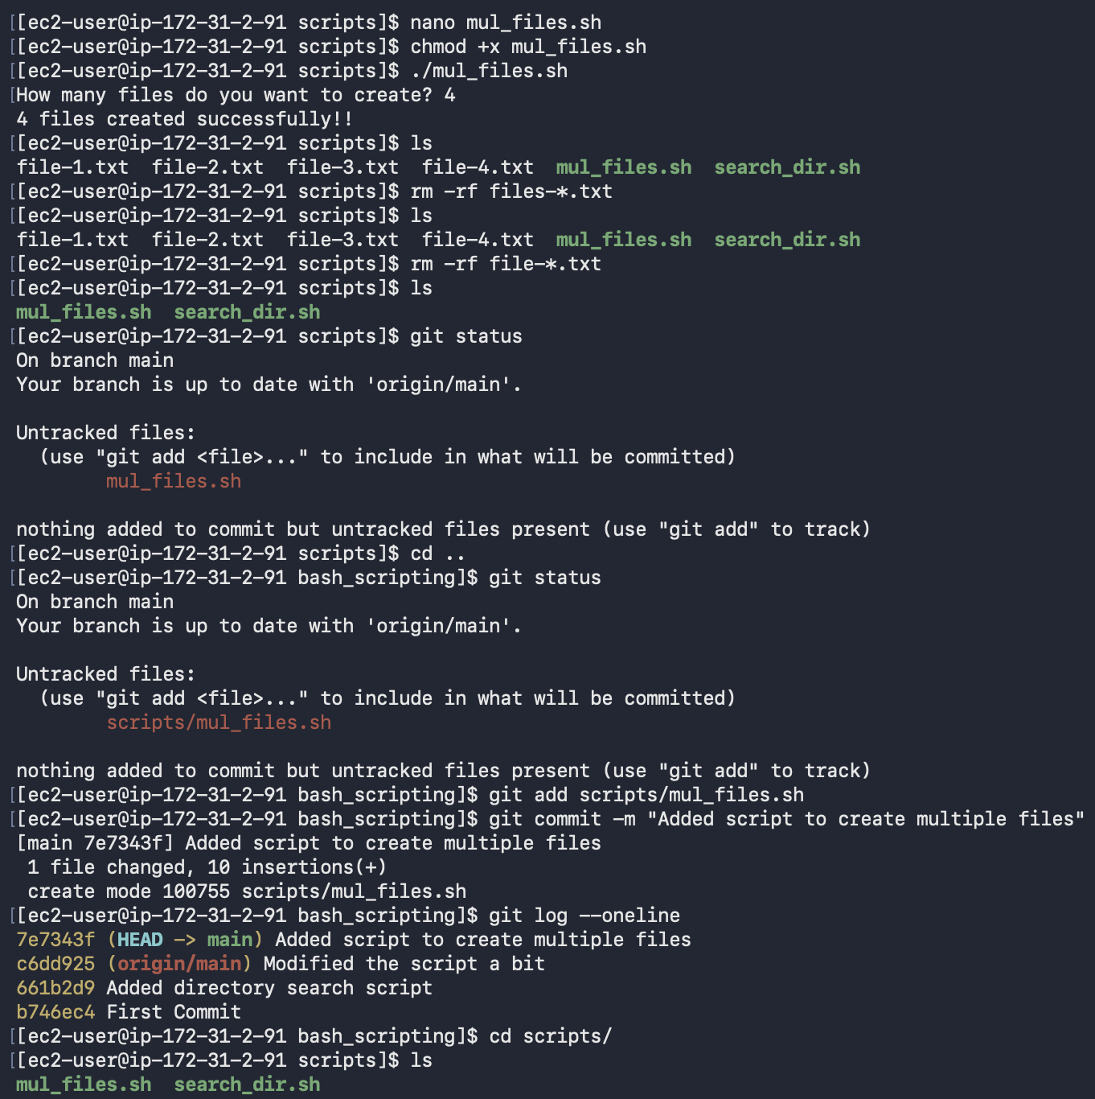
- Create a bash script to take a backup of a directory.
  - nano backup_dir.sh - Create a new file and paste the below contents
  - #!/bin/bash

read -p “Enter source directory ” source
read -p “Enter backup directory ” backup

timestamp=$(date +Y%m%d_%H%M%S)

tar -cvzf “$backup/backup_$timestamp.tar.gz” “$source”

echo “Backup completed!”
  - bash -n backup_dir.sh - Command used to validate the script
  - chmod +x backup_dir.sh - Giving execute permissions to backup_dir.sh
  - bash backup_dir.sh (or) ./backup_dir.sh - Commands to run the script
  - git add scripts/backup_dir.sh - This command adds the script to the git staging area where scripts will get ready to commit
  - git commit -m “Added a script to create a backup file” - This command commits the code into github
  - git push - This command is used to push the final code to the existing git repository.
  - git log --oneline - Command used to verify commit history
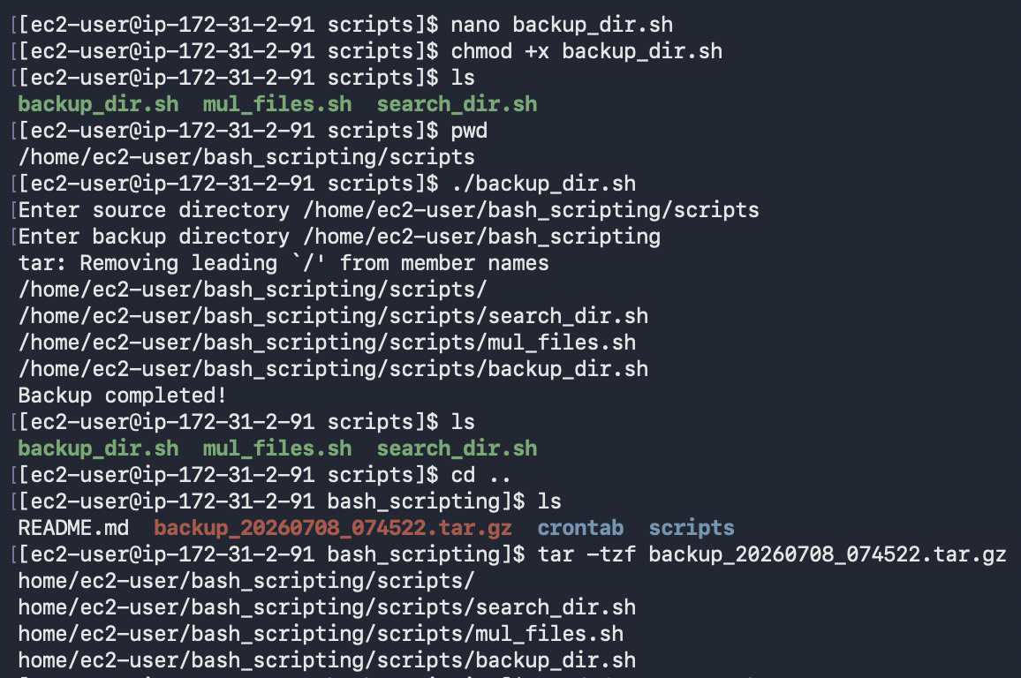
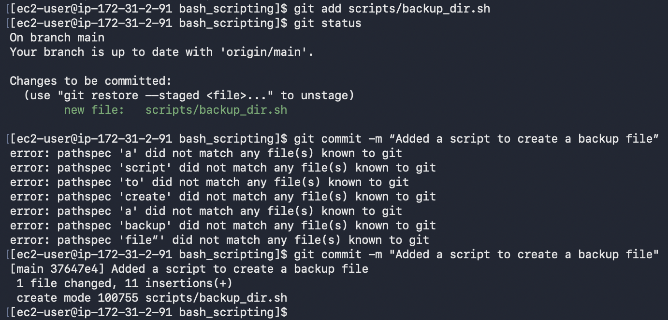

- Create a bash script to install Nginx on an EC2 server.
  - nano nginx_installation.sh - Create a new file and paste the below contents
  - #!/bin/bash

sudo yum update -y
sudo yum install nginx -y

sudo systemctl enable nginx
sudo systemctl start nginx

curl http://localhost:80
echo "nginx installation completed."
  - bash -n nginx_installation.sh - Command used to validate the script
  - chmod +x nginx_installation.sh - Giving execute permissions to nginx_installation.sh
  - bash nginx_installation.sh (or) ./nginx_installation.sh - Commands to run the script
  - git add scripts/nginx_installation.sh - This command adds the script to the git staging area where scripts will get ready to commit
  - git commit -m “Added a script to install nginx on EC2 server” - This command commits the code into github
  - git push - This command is used to push the final code to the existing git repository.
  - git log --oneline - Command used to verify commit history
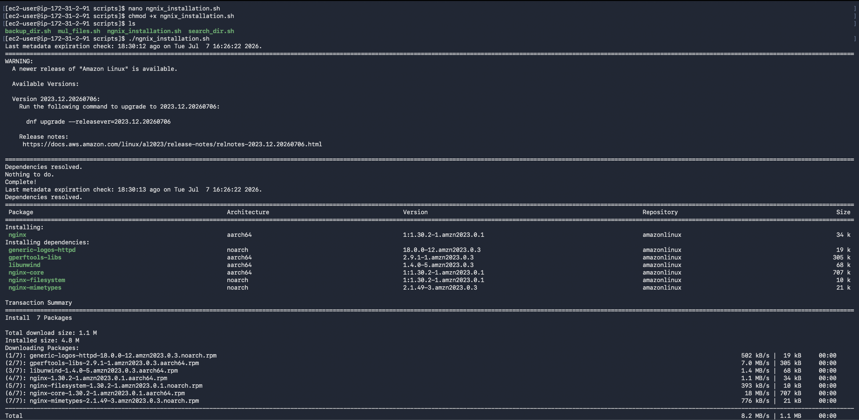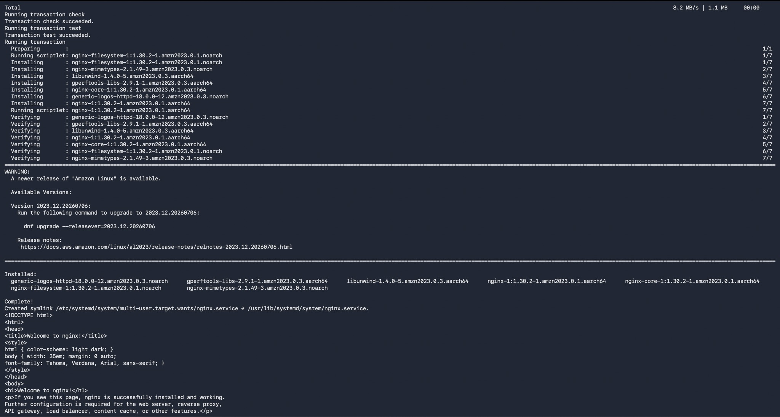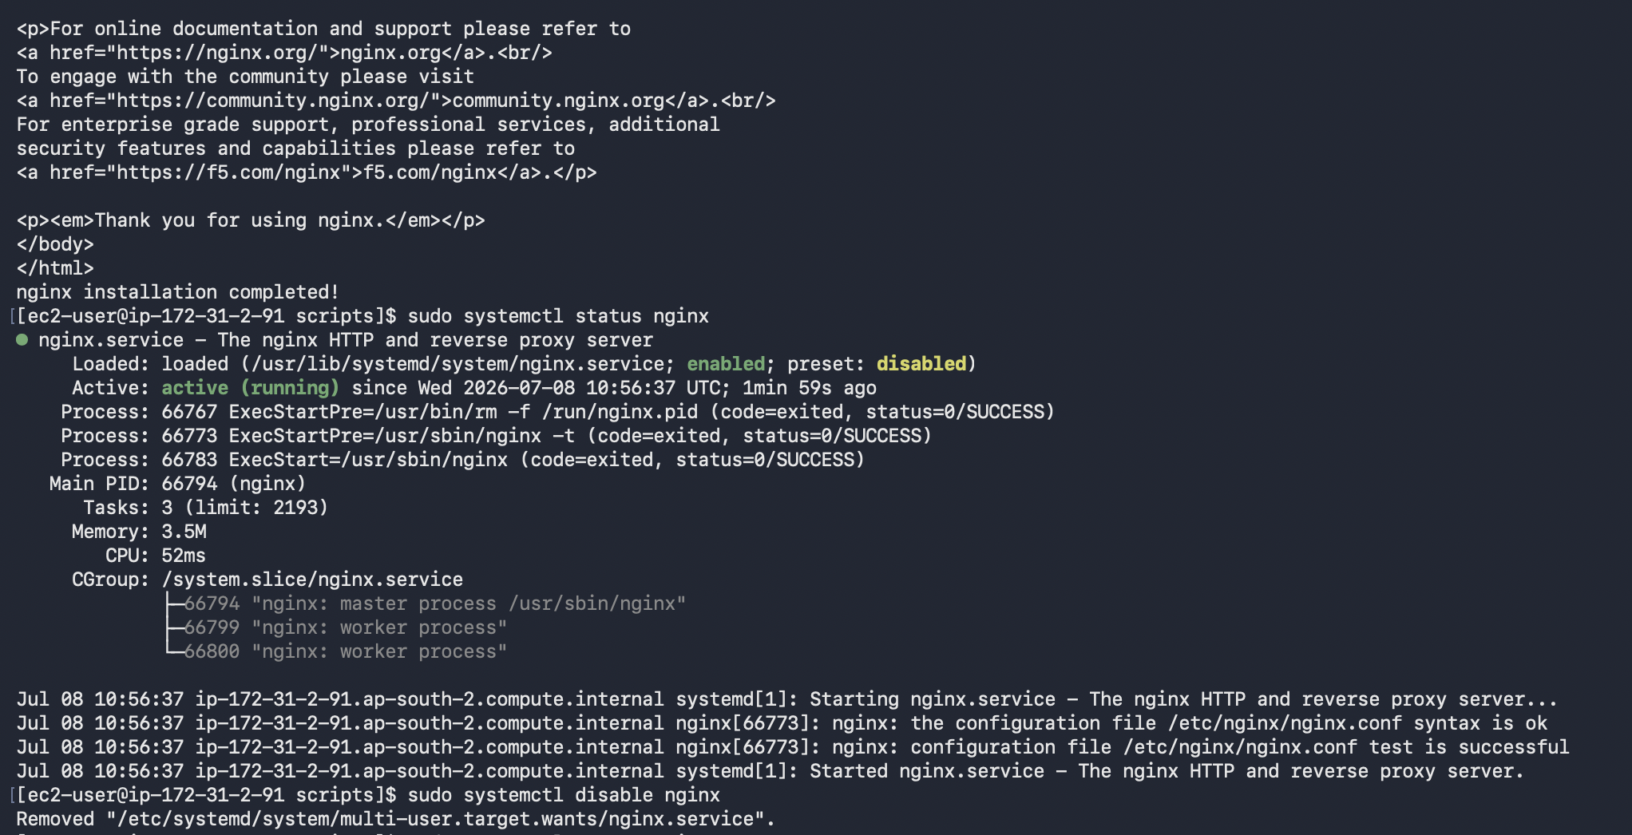
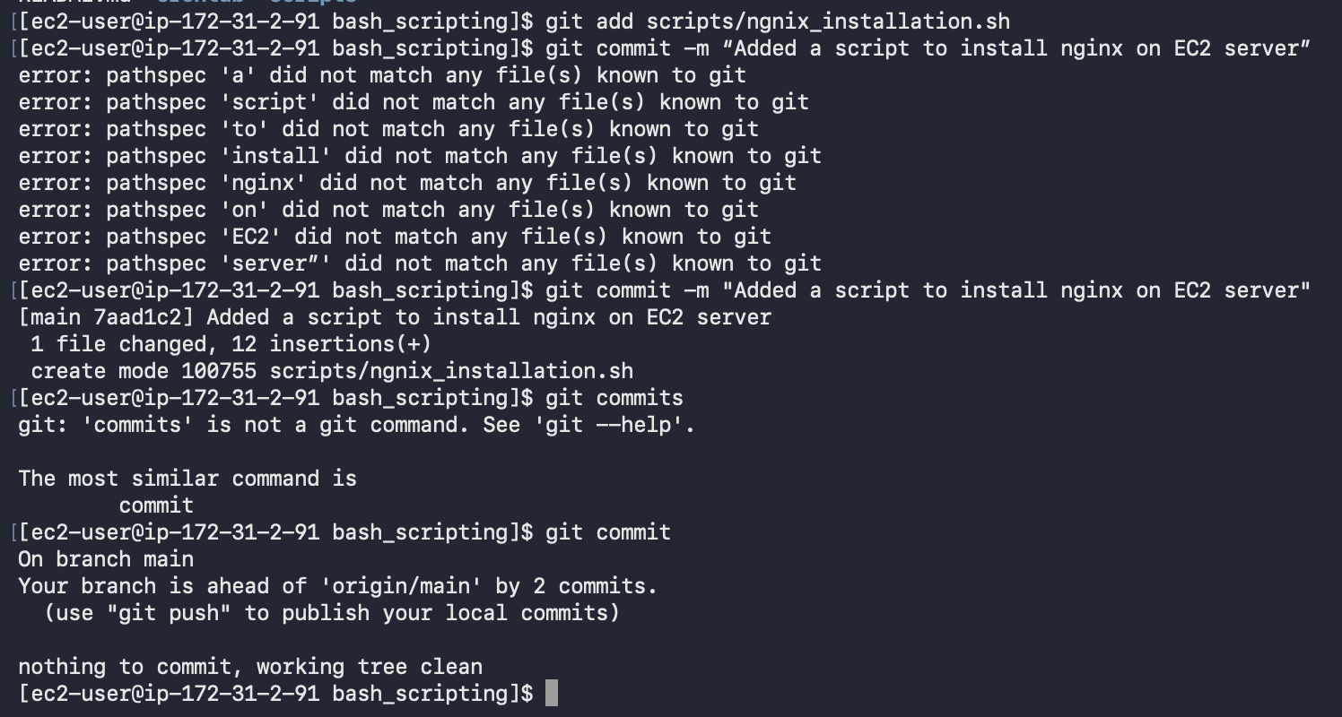

- Create a bash script to install Apache Tomcat on an EC2 server.
  - nano tomcat_installation.sh - Create a new file and paste the below contents
  - #!/bin/bash

sudo yum update -y
sudo yum install java-21-amazon-corretto-devel -y

java –version
cd /opt

sudo wget https://dlcdn.apache.org/tomcat/tomcat-11/v11.0.24/bin/apache-tomcat-11.0.24.tar.gz

sudo tar -xvzf apache-tomcat-11.0.24.tar.gz

sudo mv apache-tomcat-11.0.24 tomcat

sudo chmod +x /opt/tomcat/bin/*.sh

sudo /opt/tomcat/bin/startup.sh

echo "Tomcat installation completed."
  - bash -n tomcat_installation.sh - Command used to validate the script
  - chmod +x tomcat_installation.sh - Giving execute permissions to tomcat_installation.sh
  - bash tomcat_installation.sh (or) ./tomcat_installation.sh - Commands to run the script
  - git add scripts/tomcat_installation.sh - This command adds the script to the git staging area where scripts will get ready to commit
  - git commit -m “Added a script to install Apache Tomcat on EC2 server” - This command commits the code into github
  - git push - This command is used to push the final code to the existing git repository.
  - git log --oneline - Command used to verify commit history
Note: Apache Tomcat does not respond to ‘systemctl’ commands, therefore you need to run the shutdown.sh script to shut the server down!

In fact, if you want apache tomcat to behave like ngnix or manage the server with ‘systemctl’ commands, you need to have a tomcat.service systemd unit file. Below is the script which includes installation of tomcat and its dependencies and creating a service file.

script: #!/bin/bash

set -e

TOMCAT_VERSION="11.0.24"
TOMCAT_USER="tomcat"
TOMCAT_DIR="/opt/tomcat"

echo "========================================="
echo "Tomcat 11 Installation Started"
echo "========================================="

# Verify script is run as root
if [ "$EUID" -ne 0 ]; then
echo "Please run this script using sudo."
exit 1
fi

echo "Updating packages..."
yum update -y

echo "Installing Java 21..."
yum install java-21-amazon-corretto-devel -y

echo "Verifying Java installation..."
java --version

echo "Creating Tomcat user..."

if ! id "$TOMCAT_USER" >/dev/null 2>&1; then
useradd -r -U -s /bin/false "$TOMCAT_USER"
fi

echo "Removing any previous Tomcat installation..."
rm -rf "$TOMCAT_DIR"

echo "Downloading Tomcat ${TOMCAT_VERSION}..."

cd /tmp

rm -f apache-tomcat-${TOMCAT_VERSION}.tar.gz

wget -O apache-tomcat-${TOMCAT_VERSION}.tar.gz \
https://downloads.apache.org/tomcat/tomcat-11/v${TOMCAT_VERSION}/bin/apache-tomcat-${TOMCAT_VERSION}.tar.gz

echo "Verifying downloaded archive..."

if [ ! -f apache-tomcat-${TOMCAT_VERSION}.tar.gz ]; then
echo "Tomcat download failed."
exit 1
fi

echo "Creating installation directory..."
mkdir -p "$TOMCAT_DIR"

echo "Extracting Tomcat..."

tar -xzf apache-tomcat-${TOMCAT_VERSION}.tar.gz \
-C "$TOMCAT_DIR" \
--strip-components=1

echo "Validating extraction..."

if [ ! -d "$TOMCAT_DIR/bin" ]; then
echo "ERROR: $TOMCAT_DIR/bin not found."
exit 1
fi

if [ ! -f "$TOMCAT_DIR/bin/startup.sh" ]; then
echo "ERROR: startup.sh not found."
exit 1
fi

echo "Setting ownership..."

chown -R ${TOMCAT_USER}:${TOMCAT_USER} "$TOMCAT_DIR"

echo "Setting permissions..."

chmod +x "$TOMCAT_DIR"/bin/*.sh

echo "Creating systemd service file..."

cat > /etc/systemd/system/tomcat.service <<EOF
[Unit]
Description=Apache Tomcat 11 Web Application Container
After=network.target

[Service]
Type=forking

User=${TOMCAT_USER}
Group=${TOMCAT_USER}

Environment=JAVA_HOME=/usr/lib/jvm/java-21-amazon-corretto
Environment=CATALINA_PID=${TOMCAT_DIR}/temp/tomcat.pid
Environment=CATALINA_HOME=${TOMCAT_DIR}
Environment=CATALINA_BASE=${TOMCAT_DIR}

ExecStart=${TOMCAT_DIR}/bin/startup.sh
ExecStop=${TOMCAT_DIR}/bin/shutdown.sh

Restart=on-failure

[Install]
WantedBy=multi-user.target
EOF

echo "Reloading systemd..."

systemctl daemon-reload

echo "Enabling Tomcat service..."

systemctl enable tomcat

echo "Starting Tomcat service..."

systemctl start tomcat

echo "Waiting for Tomcat startup..."
sleep 10

echo "========================================="
echo "Tomcat Service Status"
echo "========================================="

systemctl status tomcat --no-pager

Echo
echo "========================================="
echo "Tomcat Installation Completed"
echo "========================================="
echo

echo "Java Version:"
java --version

Echo
echo "Tomcat Version:"
$TOMCAT_DIR/bin/version.sh

Echo
echo "Check Port 8080:"
ss -tulpn | grep 8080 || true

Note: The below screenshots contain only the outputs of tomcat_installation.sh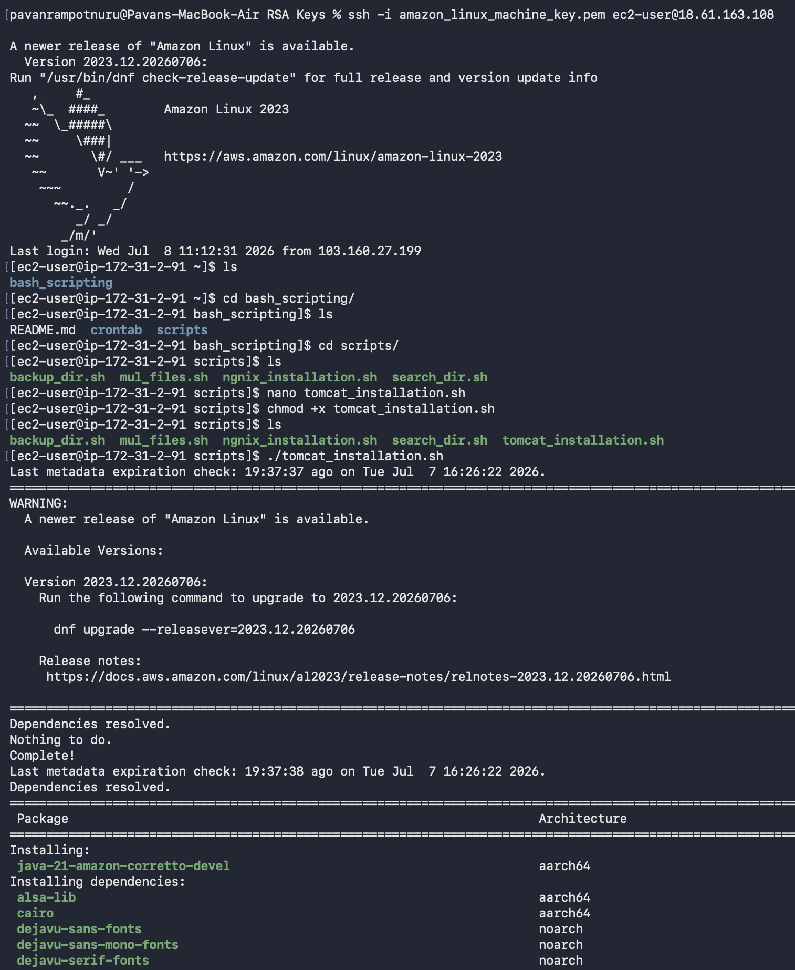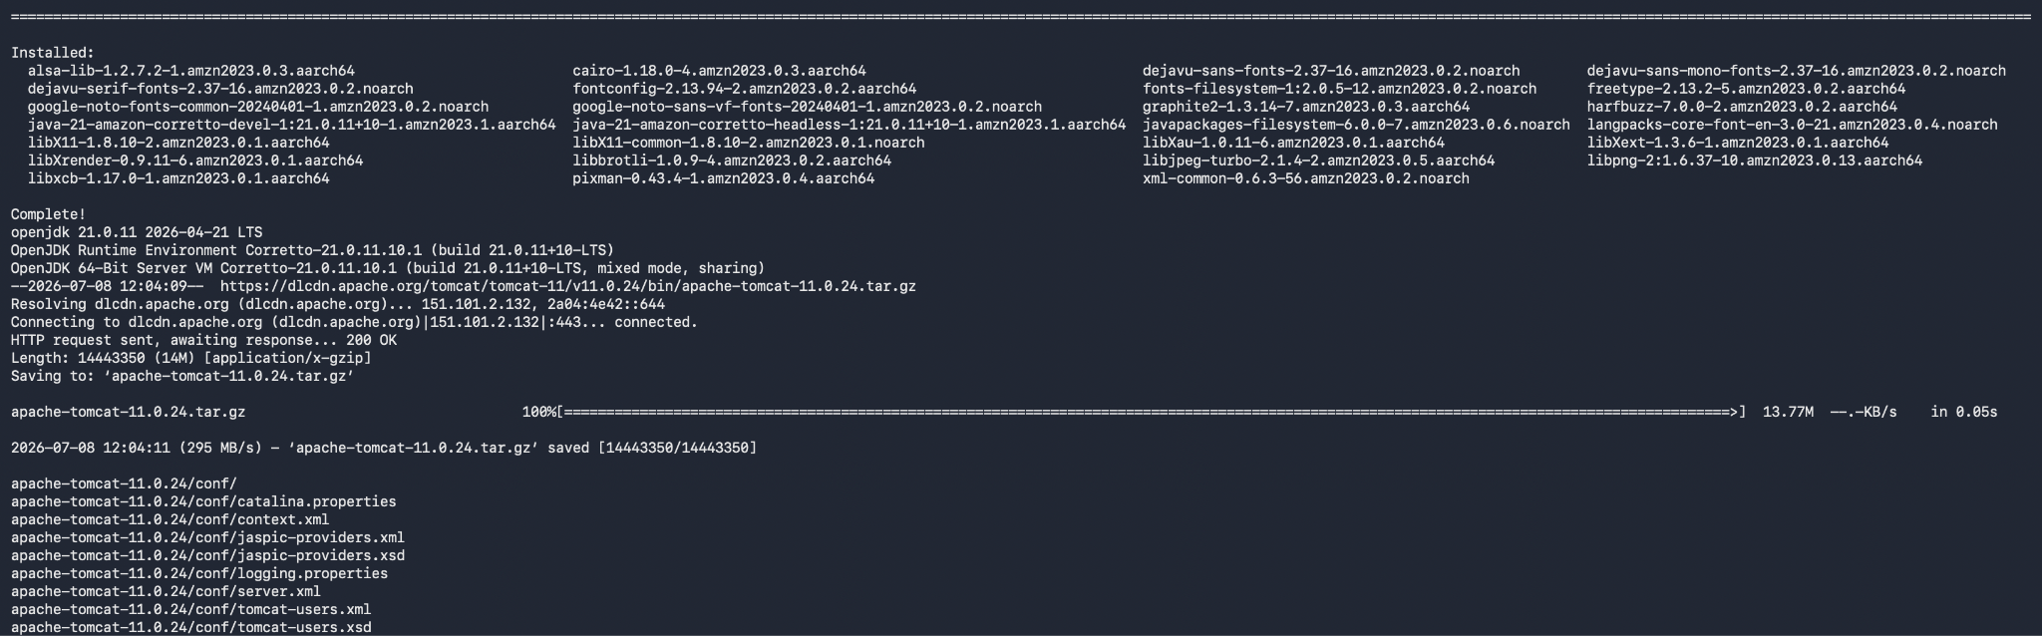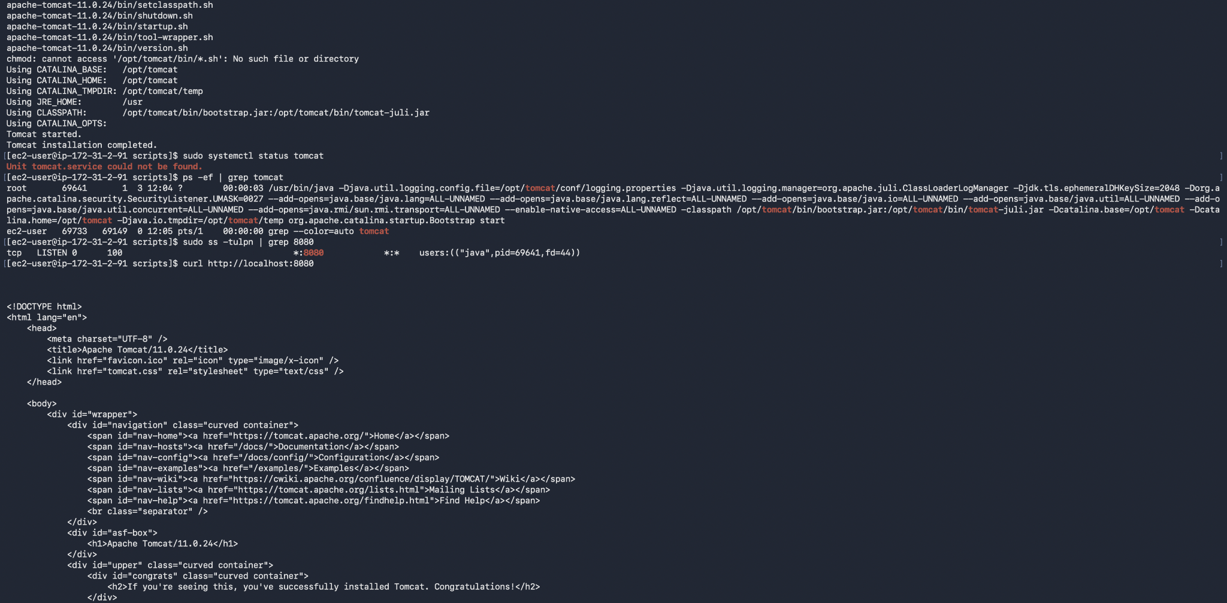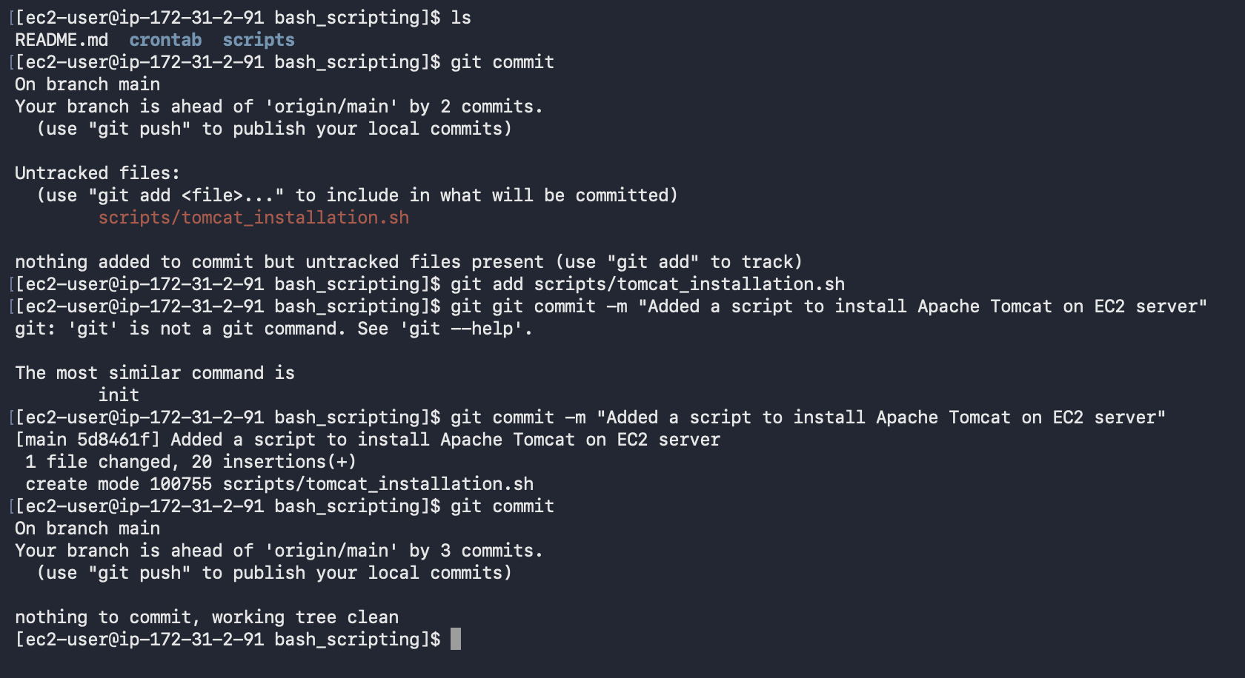
- Create a bash script to check if the Nginx service is running, if not running then script should start the service.
- nano nginx_monitor.sh - Create a new file and paste the below contents
- #!/bin/bash

if systemctl is-active --quiet nginx
then
echo "Nginx is running."
else
echo "Nginx is stopped."
sudo systemctl start nginx
echo "Nginx started successfully."
fi
- bash -n nginx_monitor.sh - Command used to validate the script
- chmod +x nginx_monitor.sh - Giving execute permissions to nginx_monitor.sh
- bash nginx_monitor.sh (or) ./nginx_monitor.sh - Commands to run the script
- git add scripts/nginx_monitor.sh - This command adds the script to the git staging area where scripts will get ready to commit
- git commit -m “Added a script to monitor Nginx and restart if stopped” - This command commits the code into github
- git push - This command is used to push the final code to the existing git repository.
- git log --oneline - Command used to verify commit history
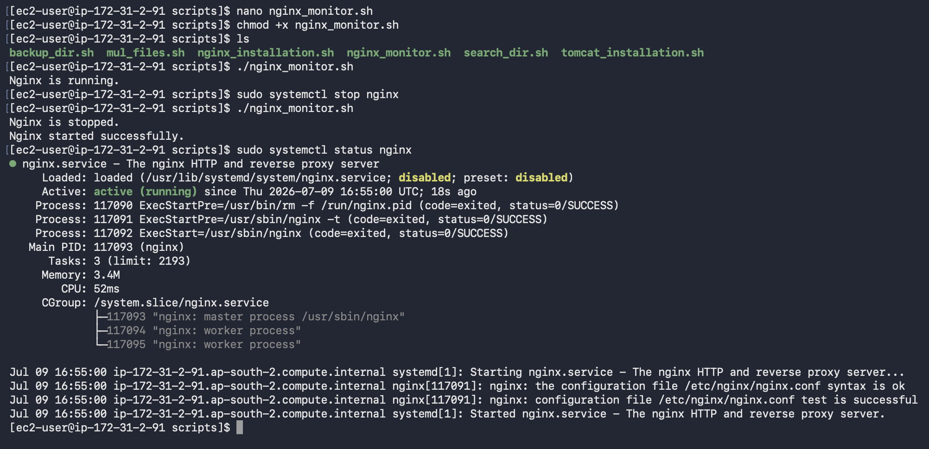

- Create a bash script for a calculator.
- nano calculator.sh - Create a new file and paste the below contents
- #!/bin/bash

read -p "Enter first number: " num1
read -p "Enter second number: " num2
read -p "Enter operation (+,-,*,/): " op

case $op in

+)
echo "Result = $((num1 + num2))"
;;

-)
echo "Result = $((num1 - num2))"
;;

\*)
echo "Result = $((num1 * num2))"
;;

/)
echo "Result = $((num1 / num2))"
;;

*)
echo "Invalid operator"
;;

esac

- bash -n calculator.sh - Command used to validate the script
- chmod +x calculator.sh - Giving execute permissions to calculator.sh
- bash calculator.sh (or) ./calculator.sh - Commands to run the script
- git add scripts/calculator.sh - This command adds the script to the git staging area where scripts will get ready to commit
- git commit -m “Added a script to monitor Nginx and restart if stopped” - This command commits the code into github
- git push - This command is used to push the final code to the existing git repository.
- git log --oneline - Command used to verify commit history
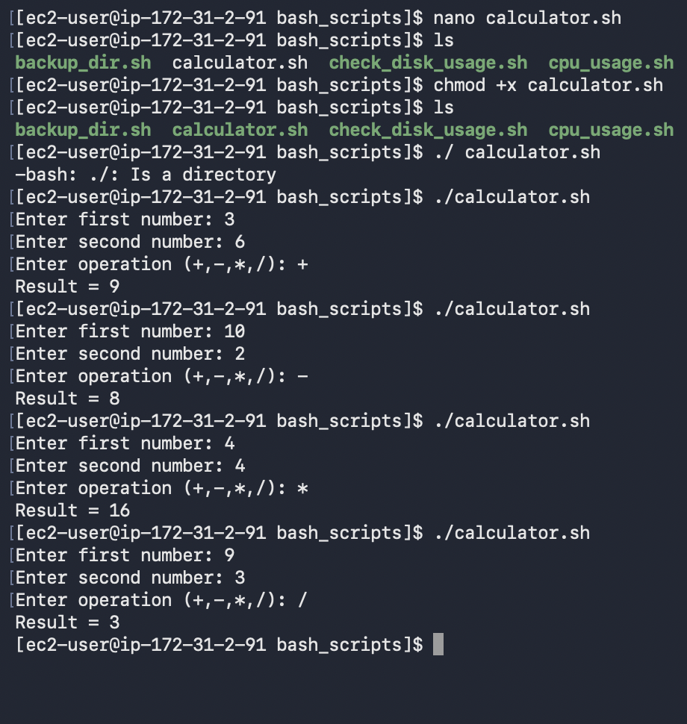

- Create a bash script to check if a directory exists, if not then create a directory.
  - nano create_dir.sh - Create a new file and paste the below contents
#!/bin/bash

read -p "Enter directory name: " dir

if [ -d "$dir" ]
then
echo "Directory already exists."
else
mkdir -p "$dir"
echo "Directory created successfully."
fi
  - bash -n create_dir.sh - Command used to validate the script
  - chmod +x create_dir.sh - Giving execute permissions to create_dir.sh
  - bash create_dir.sh (or) ./create_dir.sh - Commands to run the script
  - git add scripts/create_dir.sh - This command adds the script to the git staging area where scripts will get ready to commit
  - git commit -m “Added a script to monitor Nginx and restart if stopped” - This command commits the code into github
  - git push - This command is used to push the final code to the existing git repository.
  - git log --oneline - Command used to verify commit history
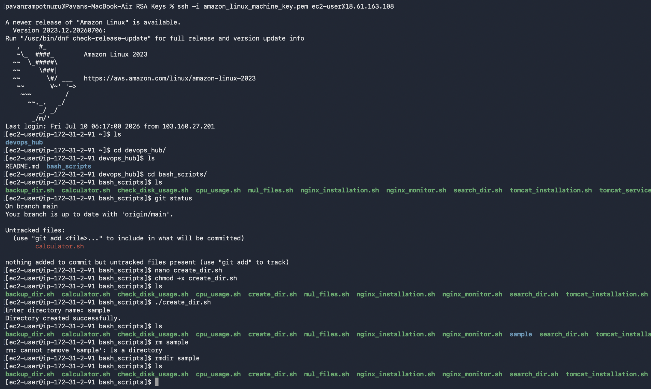
- Create a bash script to delete the last 3 lines of a file.
  - nano delete_lines.sh - Create a new file and paste the below contents
  - #!/bin/bash

read -p "Enter file name: " file

head -n -3 "$file" > temp.txt

mv temp.txt "$file"

echo "Last 3 lines removed."
  - bash -n delete_lines.sh - Command used to validate the script
  - chmod +x delete_lines.sh - Giving execute permissions to delete_lines.sh
  - bash delete_lines.sh (or) ./delete_lines.sh - Commands to run the script
  - git add scripts/delete_lines.sh - This command adds the script to the git staging area where scripts will get ready to commit
  - git commit -m “Added a script to monitor Nginx and restart if stopped” - This command commits the code into github
  - git push - This command is used to push the final code to the existing git repository.
  - git log --oneline - Command used to verify commit history
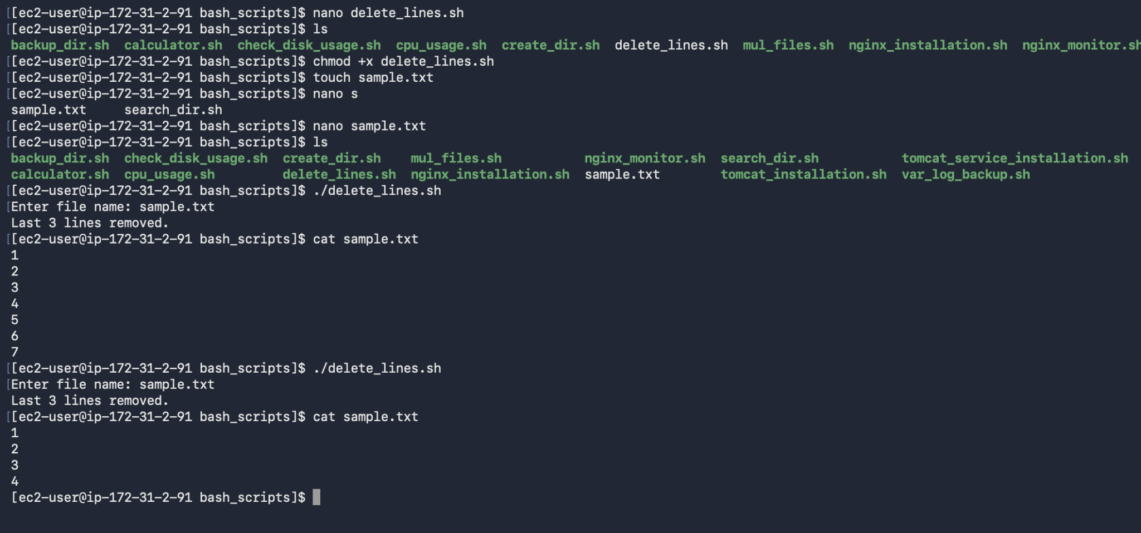

- Bash script to monitor cpu and if it is more than 80% then send email notification.
  - nano cpu_mail_alert.sh - Create a new file and paste the below contents
  - #!/bin/bash

THRESHOLD=80

CPU=$(top -bn1 | grep "Cpu(s)" | awk '{print 100-$8}' | cut -d. -f1)

if [ "$CPU" -gt "$THRESHOLD" ]
then
echo "CPU Usage is $CPU%" | mail -s "CPU Alert" your_email@example.com
fi
  - bash -n cpu_mail_alert.sh - Command used to validate the script
  - chmod +x cpu_mail_alert.sh - Giving execute permissions to cpu_mail_alert.sh
  - bash cpu_mail_alert.sh (or) ./cpu_mail_alert.sh - Commands to run the script
  - git add scripts/cpu_mail_alert.sh - This command adds the script to the git staging area where scripts will get ready to commit
  - git commit -m “Added a script to monitor Nginx and restart if stopped” - This command commits the code into github
  - git push - This command is used to push the final code to the existing git repository.
  - git log --oneline - Command used to verify commit history
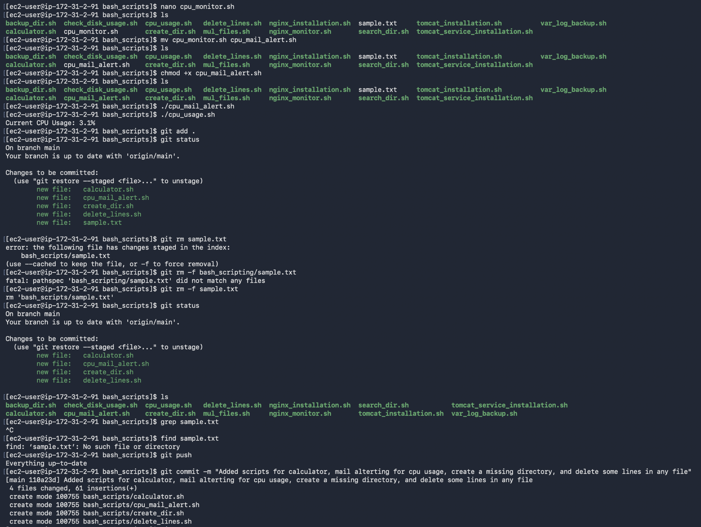
- Bash script to monitor disk space and if it is more than 80% then send email notification.
  - nano diskspace_mail_alert.sh - Create a new file and paste the below contents
#!/bin/bash

THRESHOLD=80

DISK=$(df -h / | awk 'NR==2 {print $5}' | sed 's/%//')

if [ "$DISK" -gt "$THRESHOLD" ]
then
echo "Disk usage is $DISK%" | mail -s "Disk Alert" your_email@example.com
fi
  - bash -n diskspace_mail_alert.sh - Command used to validate the script
  - chmod +x diskspace_mail_alert.sh - Giving execute permissions to diskspace_mail_alert.sh
  - bash diskspace_mail_alert.sh (or) ./diskspace_mail_alert.sh - Commands to run the script
  - git add scripts/diskspace_mail_alert.sh - This command adds the script to the git staging area where scripts will get ready to commit
  - git commit -m “Added a script to monitor Nginx and restart if stopped” - This command commits the code into github
  - git push - This command is used to push the final code to the existing git repository.
  - git log --oneline - Command used to verify commit history
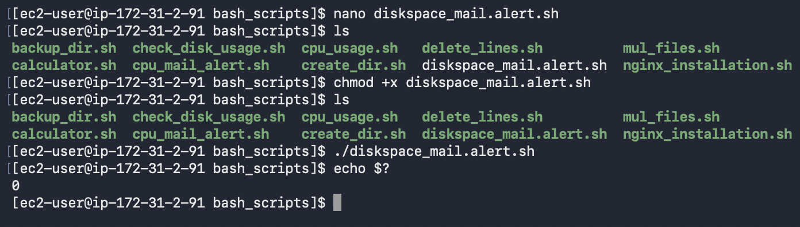

- Bash script to monitor memory and if it is more than 80% then send email notification.
  - nano memory_mail_alert.sh - Create a new file and paste the below contents
  - #!/bin/bash

THRESHOLD=80

MEMORY=$(free | awk '/Mem:/ {printf("%.0f"), $3/$2 *100}')

if [ "$MEMORY" -gt "$THRESHOLD" ]
then
echo "Memory usage is $MEMORY%" | mail -s "Memory Alert" your_email@example.com
fi
  - bash -n memory_mail_alert.sh - Command used to validate the script
  - chmod +x memory_mail_alert.sh - Giving execute permissions to memory_mail_alert.sh
  - bash memory_mail_alert.sh (or) ./memory_mail_alert.sh - Commands to run the script
  - git add scripts/memory_mail_alert.sh - This command adds the script to the git staging area where scripts will get ready to commit
  - git commit -m “Added a script to monitor Nginx and restart if stopped” - This command commits the code into github
  - git push - This command is used to push the final code to the existing git repository.
  - git log --oneline - Command used to verify commit history
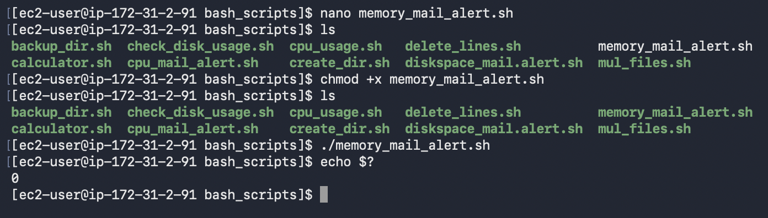

CRONTABS:
* * * * * command_to_execute
| | | | |
| | | | └── Day of Week (0-7) (0/7=Sunday)
| | | └──── Month (1-12)
| | └────── Day of Month (1-31)
| └──────── Hour (0-23)
└────────── Minute (0-59)
Why do we use cron jobs?
- Cron is a Linux scheduler used to automate repetitive tasks such as backups, health checks, monitoring, cleanup jobs, report generation, service restarts, and script execution at specific times or intervals without manual intervention.

Syntax: * * * * * /path/to/command(or)script
Example: Run a backup script at the end of every day(11:59:00)

Command : 59 23 * * * /absolute/path/of/backup.sh

Breakdown of the Timing Fields
- 59: The 59th minute.
- 23: The 23rd hour (using a 24-hour clock, this is 11 PM).
- * * *: Every day of the month, every month, and every day of the week.

Below are the steps to install cronie on your amazon linux ec2 server and setup
- Install crontab on your amazon linux ec2-server
  - sudo yum install cronie -y
- Now verify the installation by using
  - sudo systemctl status crond
- This says as inactive(dead) and start the crond service using
  - sudo systemctl start crond
- Now it will normally start and enable it to run after startup or reboot, the status active confirms that the crond services are started.
- Now use this below command to open the crontab editor,
  - crontab -e
- Add the desired cron jobs you want to run at the scheduled times. Then save and exit from the crontab editor.
- Once this is done, every cron job runs automatically at scheduled times. For this to work the server should be switched on all the time.
- If you are running your jobs on a ec2 machine or a cloud server, they all naturally use UTC timezone. To run the cron jobs in your timezone(ex. IST), either convert the times into UTC and create the cronjobs or use timedatctl command to change the timezone.
- Below is the timedatectl command to change the timezone to IST(Asia/Kolkata).
  - sudo timedatectl set-timezone Asia/Kolkata
  - sudo systemctl restart crond
Exercises: Below is the crontab_examples.txt file where all the cronjob exercises are stored.

